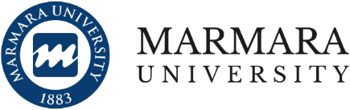
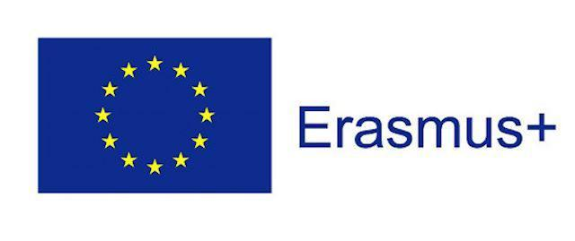
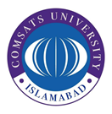

THE FIRST CALL FOR ERASMUS+ INTERNATIONAL CREDIT MOBILITY (ICM) / OUTGOING STUDENT TRAINEESHIP MOBILITY

2020/2023 PROJECT TERM

Application Period: 15-12-2022

Erasmus+ International Credit Mobility programme enables to students between Marmara University and its COMSATS University Islamabad, Lahore campus for study/traineeship mobility activities. This call includes Erasmus+ International Credit Mobility Project, contract no: 2020-1-TR01-KA107-087815, for the years 2020 – 2023. This call opens for the applications to the following ERASMUS+ ICM partners:
- Marmara University

WHO CAN APPLY?
Full-time students of COMSATS University Islamabad, Lahore campus can benefit from outgoing student traineeship mobility as long as they meet the below conditions and submit their applications by the deadline stated on this call:

- Postgraduate students must have at least 3.25 / 4.00 cumulative GPA
- Students must have at least finished one academic year prior to the start of the exchange period. Students at their preparatory year are not eligible to apply for this call.
- Applicants must show proof of English proficiency in the application process
- The students who are at their last semester are advised not to take part in any study abroad program due to possible complications regarding late arrival of transcript and graduation requirements.

HOW TO APPLY?
- Interested students should submit their application to by bringing the below-mentioned documents to Manager IRCBM
- Valid COMSATS English Language Certificate, indicating that the mode of teaching was English language
- Official Transcript
- Filled application form that can be downloaded here

SELECTION OF MOBILITY CANDIDATES
Following the application deadline, Marmara University Erasmus+ Commission will make the eligibility check for all the applications.

Marmara University Erasmus+ Commission will evaluate your application on the basis of the following criteria:
- Academic GPA (70%)
- Language Language (10%)
- Interview (20%)
- -10 for previous participation in any Erasmus’ programs within current study level
- Disabled students (The statement from a doctor or other relevant authority confirming the special needs should be submitted to the International Relations Office during the application period): +10 points
- Participation in Erasmus programme in the country of nationality: - 10 points
- Relatives of martyr or veteran *: + 10 points

MOBILITY DURATION
2 months. All motilities must be completed until 31 May 2023.
Erasmus+ International Credit Mobility for Traineeship needs to be at least 2 months long. Any mobility under that threshold will be invalid.

GRANT

ICM with Grant Option
Students may be awarded an Erasmus+ ICM grant to help cover their living expenses during their mobility period. Grant payment is subject to the amount of applications received and availability of funds from the Turkish National Agency. Please note that Erasmus grants are only contribution, meaning may not suffice for all your expenses and students are responsible for their own travelling costs and living expenses during the exchange.

In addition to the Erasmus+ ICM individual grant, selected students for Erasmus+ ICM grant receive travel support.

Partner Countries | Monthly Individual Grant (€) | Travel Support (€)
Turkey | 800 | 530

Total amount you receive is calculated on the basis of months and days you actually spend in exchange.

The grant is usually paid in two instalments:
- ​The first installment (80% of the total amount and total travel support) is paid within 45 days of signing the mobility grant agreement which has to be signed by student and COMSATS University.
- The remaining 20% is paid after the participant returns and upon proper delivery of all the required final mobility documents. This second installment will not be paid until all the required documents are submitted.
IMPORTANT NOTE: You will not be able to receive remaining 20% of the Erasmus grant if you cannot receive satisfactory marks in 2/3 of the courses that you take at the host (partner) university.

Additional Grant Opportunity for Students with Special Needs
Additional grants are available for students with special needs who wish to participate in Erasmus+ ICM programme and where participation would not be possible without extra financial support. In order to learn more about additional grant opportunities for students with special needs, please get in contact with International Relations Office.

Students with special needs may receive additional grant for their study mobility abroad. Please check our webpage for the detailed information.

Final Note
Any queries regarding application process are to be made to the Manager IRCBM ircbm@cuilahore.edu.pk
We wish you best of luck with your applications.

