

# INFORMATION TECHNOLOGY

SERVICES

## COMSATS University Islamabad, Lahore Campus

Defence Road off Raiwind Road, Lahore

No. +92-42-111-001-007 Fax: +92-42-9203100 URL: <https://lahore.comsats.edu.pk/>

Tel.

### INFORMATION TECHNOLOGY SERVICES

We welcome you to COMSATS University for a bright future ahead. Over a due course of time, you would experience different IT Services offered to you by **Information Technology and Services (ITS)** at COMSATS University (CUI), Lahore campus. These IT Services would play a pivotal role to your learning curve and growth.

It is imperative that you utilize these resource in the most beneficent and productive manner. We provide you with the best IT services using **Single Sign On (SSO)** authentication. Our CUOnline Student portal facilitates the students to better keep a track of their academic progress while providing access to excellent digital academic resources. A glimpse of the Student Portal is given below

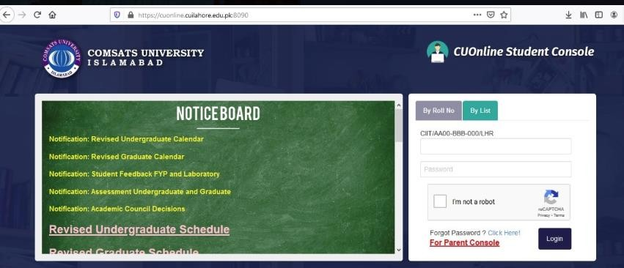

Enter the URL https://cuonline.cuilahore.edu.pk:8091/ in your Browser to access the student portal login page. Enter the username and password of your account to Login. Once you are logged in, you will be shown your Dashboard. The dashboard will display you registered courses, corresponding teachers, class, and attendance summary.

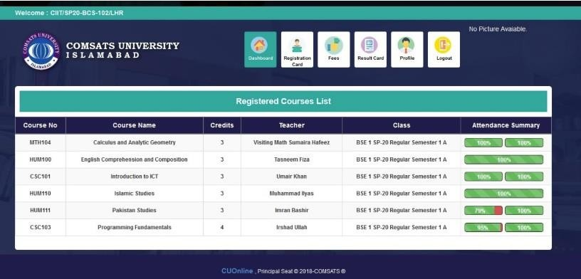

## COMSATS University Islamabad, Lahore Campus

Defence Road off Raiwind Road, Lahore

No. +92-42-111-001-007 Fax: +92-42-9203100 URL: <https://lahore.comsats.edu.pk/>

Tel.

Single Sign On

(SSO)Credentials

##### CUI Lahore Domain Username and Password will be sent on personal Email Addresses and SMS to personal Mobile no, provided by the student.

CUOnline (Student Portal) Credentials

##### The Username and Password of CUOnline Student Portal will sent on the students personal Email addresses and SMS to personal Mobile no.

###### ITS also provides following excellent services for its users:

* + Official Student Email account on the Campus domain.
  + Centralize Authentication (SSO) and Network storage.
  + Computer Labs Authentication, Wi-Fi (eduroam): The username and password that you would need to access the WI-FI "eduroam", official email address, Library Services and access to the computer labs have been emailed at your, personal email address.
  + Virtual Private Network Access: A VPN setup guide is available at COMSATS University CUI Website Link https://lahore.comsats.edu.pk/links/quicklinks.aspx

###### PRECAUTIONS

It is strongly recommended that you do not share your credentials with your friends. In case of any suspicious activity, your account would be suspended. Kindly change your password as soon as possible from Computer lab or using online website Link <https://secure.cuilahore.edu.pk/>.Your password must be 8 characters or above using the combination of alphabets, upper & lower case, numeric and special characters.

Note: Remember that Sharing of password PIN and login information with non-relevant person(s) is a crime that may lead to punishment