Style Guidelines for Final Year Project ReportsTitle of the Project
Final Year Project Proposal
Session 20xx-20xx
A 4th Year Student

A project submitted in partial fulfillment of the requirements for the Degree
of
BSc. (Hons.)BS in Computer Science / Software Engineering / Artificial Intelligence



Department of Computer Science
COMSATS University Islamabad (CUI), Lahore Campus

Project Registration
Project ID (for office use)
Type of project |  |  | [ ] Traditional [ ] Industrial [ ] Continuing
Nature of project |  |  | [ ] Development [ ] Research & Development
Sustainable Development Goals(SDGs) |  |  | [ ] Good Health and Well-Being [ ] Quality Education  [ ] Industry, Innovation, and Infrastructure [ ] Gender Equality  [ ] Decent Work and Economic Growth [ ] Climate Action
Area of specialization |  |  | [ ] Artificial Intelligence (AI) [ ] Blockchain [ ] Cybersecurity  [ ] Data Science and Analytics [ ] Game Development  [ ] Internet of Things (IoT) [ ] Natural Language Processing (NLP)  [ ] Mobile App Development [ ] Web Development
Project Group Members
Sr.# | Reg. # | Student Name |  | Email ID | Phone # | Signature
(i) | Group Leader
(ii)
(iii)
Declaration: FYP group members have cleared all prerequisite courses For FYP-I as per their degree requirements.
For BS (Computer Science), BS (Software Engineering), and BS (Artificial Intelligence)
(CSC241 Object Oriented Programming, CSC291 Software Engineering Concepts, CSC270 Database Systems, HUM102 Report Writing Skills)
Plagiarism Free Certificate
This is to certify that, I am ________________________ S/D/o _______________________, group leader of FYP under registration no CUI /_________________/LHR at the Computer Science Department, COMSATS Institute of Information Technology, Lahore. I declare that my FYP proposal is checked by my supervisor and the similarity index is ________% that is less than 20%, an acceptable limit by HEC. The report is attached herewith as Appendix A.
Date: _________ Name of Group Leader: ______________________ Signature: __________
Name of Supervisor: __________________ Co-Supervisor (if any):_________________
Designation: _____________________ Designation: _____________________
Signature: _____________________ Signature: _____________________

General Guidelines for Project Proposal Writing
Important note about writing a proposal: Proposals are informative and persuasive writing because they attempt to educate the reader and to convince the reader the importance of the project to be conducted. The goal of the writer is to make the reader believe that the provided solution is practical and appropriate. In persuasive proposal writing, the case is built by demonstration of logic and reason in the approach taken in the solution. The effectiveness of your proposal will depend on your ability to explain the nature, context and scope of your project.
All proposals should have all of the following sections, it is recommended that you must follow the listed order, it ensures logical flow to your writing.
- Abstract
- Introduction
- Problem Statement
- Project Objectives
- Related Work
- Proposed Methodology and Architecture
- Success Criterion
- Team Roles and Responsibilities
- Tools and Technologies
- References
Before starting write up, first, confirm that the correct template has the correct paper size. This FYP proposal template has been tailored for output on the A4 PAPER SIZE. Specify paper width according to dimensions shown in Figure 1. Throughout the document, the font face “Times New Roman” MUST BE used for the text and font size of 11 MUST BE used. Line spacing for the entire document MUST BE 1.0 and paragraph spacing between two paragaphs within a section MUST BE 0 pt “Before” and 6 pt “After”. Distribute paragraphs text evenly between both margins to give the document a clean and crisp look, and this task can be performed by using justify paragraph option in MS word.
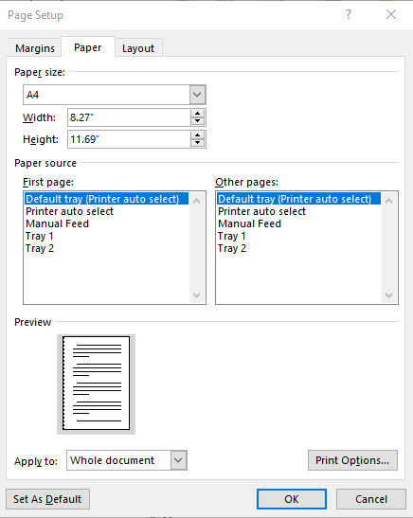
Figure 1. Paper size settings.
Ensure page margins are according to the margin values shown in Figure 2.
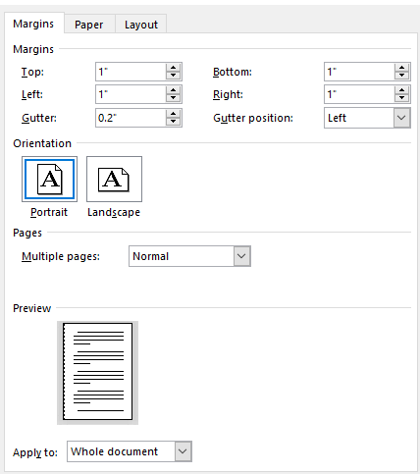
Figure 2. Template page margins.
It is also recommended that all proposals use headers for each section with the MAXIMUM of 2 level subheading. Subheading level more than 2 is strongly discouraged.

Template Heading (Heading-1)
Each section should start with heading font size 16, bold, and font face “Times New Roman”. First, outline the proposal in different sections and try to include relevant heading. If it is required to split the section into sub-headings.

Selecting a Sub Heading (Heading-2)
The heading font for sub-heading should be font size of 14, bold, and font face “Times New Roman.

Figures and Tables
Use the following instructions to create tables and figures. All the figures and tables must be cross-referenced in the text. For example, Figure 1 refers to the to the paper size, and margins of the document. Similarly, all tables should be cross-referred in the text. For example, Table 1 shows the individual task of each group member. Figure and Table labels and captions should be font size 10, “Times New Roman”. Figure captions should be below the figures; table captions should appear above the tables. Insert figures and tables after they are cited in the text. Use words rather than symbols or abbreviations when writing Figure labels to avoid confusing the reader. Use the abbreviation “Figure 1” and “Table 1”, even at the beginning of a sentence. Ensure that the figure and table are within the page margin mentioned in Figure 2.

Failure to Submit FYP proposal on time
Any student or group who fails to submit a project proposal on time breaches regulation and will not be registered in FYP-I.

ABSTRACT
Abstract section is MANDATORY and should comprise an abstract idea of the project (the problem you are solving) and its significance, the project's specific objectives, the proposed methodology/design, and the expected outcomes or impact of the project. Abstract should be concise, a single paragraph, TYPICALLY UNDER 250 WORDS, and serve as a standalone summary to give a clear understanding of the project's purpose and scope.
Here is the structure (rough idea) to write an abstract in a single paragraph.
- Domain background - 4 lines
- Problem statement - 4 lines
- Proposed solution - 4 lines
- Results or outcomes - 4 lines
Previous Project Objectives and Features
This section is only MANDATORY IN CASE OF CONTINUING PROJECT and should highlight the objectives and features of the previous project and provide clear comparison with the objectives and features of the proposed project, showing significant differences for it to be considered as a complete one year FYP.

Introduction
This section is MANDATORY and will introduce the project and explain the context by explaining the background to the work you propose and describe the purpose, motivation or relevance of the project. You must describe why the problem is important and must convey why you want to take this project and what you hoped to learn from your project. The goal of the project and the main focused objectives of the project are discussed in this section. You can focus on answering the following questions. What is background to the project? Why is the problem being solved worth solving? What are the existing approaches (if any) that solve this problem and what do they lack? How will you address those issues and what do needs to be achieved to deliver the project? You need to demonstrate your understanding of the practical problem at hand and the potential results that are expected.
The description in the introduction section must answers given in the previous paragraph. It should give details of specific goals to be achieved and precise characterizations of the methods used in the process. You should identify the main sub-tasks that make up your complete project and outline the algorithms or techniques to be adopted in completing them. A project description should give criteria that can be used at the end of the year to test whether you have achieved your goals and should back this up by explaining what form of evidence to this effect you expect to include in your dissertation. The introduction section should comprise A MINIMUM OF 500 WORDS.
Here is the structure (rough idea) to write introduction of 1 to 2 pages maximum.
- Domain background - 20 lines 2 paragraphs
- Motivation and significance of the project with refrence(s) - 10 lines 1 paragraphs
- Objectives and scope of the project (what is included and what is not) 10 lines 1 paragraphs
- Proposed solution - 10 lines 1 paragraphs
- Results or outcomes - 10 lines 1 paragraphs

Problem Statement
This section is MANDATORY and highlights the underlying issue or research gap that drives the need for a particular study or solution. It explains why the problem is important, what challenges exist in the current approaches, and how addressing this issue can create value or improvement. In essence, it identifies the limitations of existing methods, technologies, or practices and emphasizes the significance of overcoming them. A well-written motivation/problem statement sets the context by linking the problem to real-world applications, demonstrating its relevance, and justifying why the proposed work is necessary. It provides a clear rationale that not only defines the scope of the study but also attracts interest by showing the potential impact of solving the problem. A problem statement should comprise a single paragraph having not more than 10 lines.

Project Objectives
This section is MANDATORY and lists the goal and the main focused objectives of the project. The proposal must clearly state well-defined objectives that can be directly linked to measureable final outcomes of the project. Objective statements should be precise and to the point, each objective maximum of two lines. For example, the project objectives may start with the following keywords:
- To collect the dataset…
- To develop a system/platform..
- To introduce an approach…
- To build an architecture…..

Related work
This section is MANDATORY and will provide literature survey of the topics related to the proposed project. The main reasons for using information from external sources are either to complement the contents of the work with relevant data or to provide a different opinion on the issue stated. In both cases, it means adding credibility to the project, making it look more trustworthy and complete. You should create an analytical review of the previous scientific works on the topic or explore related development. You have to provide the historical background and inform the reader about current achievements in research/development. Using only proven credible sources from latest journals, conferences, and books accepted in academic circles is vital a and a short overview of these sources must be provided in this section. All sources used have to be APPROPRIATELY CITED THROUGH THE TEXT. It is necessary to study the structure of such work to write a strong final year project proposal. Moreover, a clear scheme will make a formal proposal easier to read.
The Reference section is situated at the end of the paper. It should follow IEEE references style, available in Microsoft word as shown in Figure 3, and display sources in the order in which they first appear in the document. Proper format should be following when citing journal acticles, conference papers, weblinks, technical reports etc.
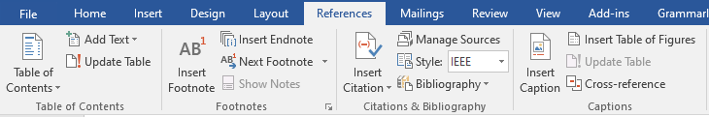
Figure 3. Word references tab.
Sample Text: For example Lydda et. al. [1], explains the use Of VSP resource rooms to support group work in a learning environment. Hideyuki et. al. [2], propoosed FreeWalk: a supporting casual meetings in a network. For more details on how to add citations in a word document, you can visit the following links [3], [4].

Proposed Methodology and Architecture
This section is MANDATORY and provides insight into what methodology you will employ in the development of the envisioned system. It is the systematic, theoretical analysis of the methods applied to your study. It can comprise step-by-step procedures, flowcharts, block diagrams or algorithms of the proposed system.

Success Criterion
This section is MANDATORY and must specify what it means for the project to be a success? How will the project team measure success? Success criterion is the specific, measurable, and agreed-upon standards used to determine if a project has achieved its objectives and met its goals that are defined in Section ‎3 . This criteria serve as a benchmark for evaluating project outcomes and must be defined during the project's initial planning phase. It is advisable to choose a reasonably modest but verifiable success criterion which you are as certain as possible can be met; this means that your project report can claim your project not only satisfies the success criterion but potentially exceeds it. Projects that do not satisfy the success criterion are, as in real life, liable to be seen as failures to some extent.
Success is the way to reach the defined project objectives (in Section ‎3) if it is according to the project proposal and satisfies all the goals and objectives listed in the document. Success requires the acceptance of the project by the supervisor and satisfaction of the client if it is other than your primary supervisor.

Team Roles and Responsibilites
This section is MANDATORY FOR GROUP PROJECT. Please mention roles and responsibilities of each team member, mentioning individual tasks each member will be responsible for, in the table indicating individual tasks and justify the one-year effort of two or three students. The expected individual task list with the tentative plan is given in Table 1 below.
Table 1. Individual Tasks
Team Member | Activity | Tentative Date
<Name 1> | Activity 01 | <Date>
 | Activity 02
 | Activity 03
 | Activity 04
 | <Activity n>
It is also MANDATORY to provide a GANTT CHART to clearly illustrate the project schedule. As per individual tasks mentioned in Table 1, the Gantt chart shall graphically represent which tasks would be done in which duration, i.e., starting date, end date. What tasks shall be done in parallel, and what tasks shall be done in series? Duration of individual task. (View few samples from the internet before making your own to get ideas)

Tools and Technologies
This section is MANDATORY and provides a list of tools and technologies that the FYP group is planning to use in the project.

References
This section is MANDATORY and you must provide references (IEEE style) when appropriate to justify your study. These refernces must be cited in the text (e.g., introduction/background), also cross check if the refrence is same as cited in the text. You must display sources in the order in which they first appear in the document. Proper format should be following when citing journal acticles, conference papers, weblinks, technical reports etc. For R&D projects: minimum refrences should be 10, and for development project minimum refrences should be 6.

[1] | L. M. Lau, J. Curson, R. Drew, P. Dew and C. and Leigh, "Use Of VSP Resource Rooms to Support Group Work in a Learning Environment," Journal Paper Example, vol. 99, p. 2, 1999.
[2] | H. Nakanishi, C. Yoshida, T. Nishimura and T. and Ishida, "Freewalk: Supporting casual meetings in a network," in Proceedings of the 1996 ACM conference on Computer supported cooperative work, Boston Massachusetts USA, 1996.
[3] | G. Coach, "How To Reference In Microsoft Word 2025: Full Tutorial With Examples Of Citations & Bibliography," 2024. [Online]. Available: https://www.youtube.com/watch?v=wnviwr-CF2w&t=416s. [Accessed 23 6 2025].
[4] | M. Inc., "Add citations in a Word document," [Online]. Available: https://support.microsoft.com/en-us/office/add-citations-in-a-word-document-ab9322bb-a8d3-47f4-80c8-63c06779f127. [Accessed 23 6 2025].

Appendix A

Include here the 1st page of Turnitin Report (MANDATORY)
Every supervisor has his/her own Turnitin account. If not, then supervisors are requested to get the account from Library as soon as possible.

Appendix B

Include here the 1st page of AI Report generated through Turnitin (MANDATORY)
Every supervisor has his/her own Turnitin account. If not, then supervisors are requested to get the account from Library as soon as possible.

