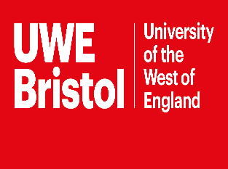 | UWE Millennium  Scholarship for  International Students

Brief Description:
The University of the West of England, Bristol offers the Millennium Scholarship to international students who will be required to undertake an internship working within the International Office or other departments, and will also be required to undertake ambassadorial activity for the University throughout the duration of the course.

Course Level: Master’s Degree

Subject(s): Any Postgraduate Programme offered at the University except MBA, BPTC, LPC, GDL, MSc Robotics, PhD‘s and continuing professional development courses

Grants Full tuition fees for one academic year.

Eligibility: To be eligible for the scholarship:

- Have achieved the equivalent of a British 1st in an undergraduate degree.
- Hold an unconditional offer or a conditional offer where IELTS or equivalent English language is the only condition.
- Be a new student to UWE Bristol with no previous UK study.
- Be classed as overseas for fees purposes.
- Not be a sponsored student or in receipt of another scholarship/award.
- Provide official transcripts at the time of application.

Deadline: 17 Nov 2017 (annual)

For more detail about eligibility and how to apply, please visit:
http://www1.uwe.ac.uk/students/feesandfunding/fundingandscholarships/internationalstudentfunding/uweinternationalscholarships/postgraduatescholarships.aspx

SEARCHED BY: Ghazanfar Ali

