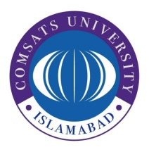
COMSATS University Islamabad (CUI), Lahore Campus
Defense Road, Off Raiwind Road, Lahore
UAN:042-111-001-007 Ext: 818-819 Tel; 042-99204779

Date: ______________

Petty Cash Reimbursement Form
CUI-LHR-/ACC/PTYCASH/01
Department Name …………………………

Name (Petty Cash Custodian)………………………….. Cash Limit (Rs.)…………….

Sr. # | Description with purpose | Expense(s) Nature | Amount (Rs.)
Grand Total:
In words:

Recommended by (Custodian/HOD)

Signature: _________________

[For official use only]
Checked By: MEHDI RAZA (Asst. Treasurer) Signature:__________________

Approved by: Nagina Sahfi (Additional Treasurer) Signature:__________________

Bank Payment Voucher
Voucher No……………
Pay to:…………………………………….. Amount (Rs.)…………

Bank A/c………………………… Cheque No:………………………….. Date………………..

Income tax………………….. GST……………….. RM……………..….

Posted By:

Name: Abdul Rahim Signature:……………………… Date……………………..

